Table of Contents

Question 1 2

Question 1.1 2

Table 1 True Table 1

# Question 1

## Question 1.1

Answer content

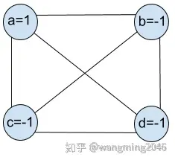[1]

Figure Weight Diagram [1]

|  |  |  |  |  |
| --- | --- | --- | --- | --- |
|  |  |  |  |  |
|  |  |  |  |  |
|  |  |  |  |  |

Table True Table [2]

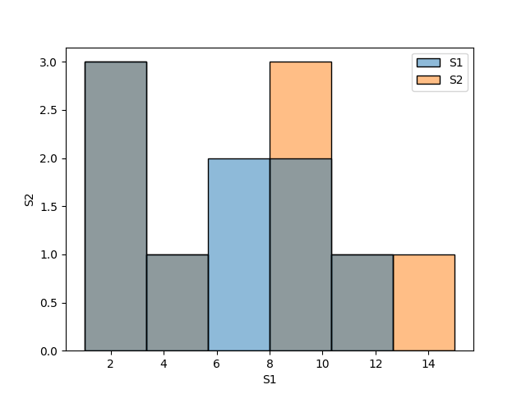

# References

|  |  |
| --- | --- |
| [1] | Raistlin, “Hopfield网络的基本,” 16 4 2023. [Online]. Available: https://zhuanlan.zhihu.com/p/116908556. |
| [2] | J. Dean, “Google Research, 2022 & beyond: Language, vision and generative models,” *Computer Science,* pp. 187-189, 2023. |

1. dfsdfsdf